Retrospective study of celiac disease in Benghazi medical centre from first of June 2021 up to 30th of June 2024

Amina Baleid Mohamed younis ¹, Abeer Jaballah ², Esraa Ramadan ³, Asmaa Masoud ⁴, Rahma Abdelhakim ⁵, Amal Ali Arhoma ⁶
^{1,6} Department of Histology, Faculty of Medicine, University of Benghazi, Benghazi- Libya
^{2,3,4,5} Department of Cytotechnology, Faculty of Biomedical Science, Benghazi university, Benghazi- Libya
Email: amina.younis@uob.edu.ly

دراسة لمرض السيلياك او الداء البطني في مركز بنغازي الطبي في الفترة من بداية يونيو 2021 الي 30 يونيو 2024

أمينة بلعيد محمد يونس¹، عبير جاب الله ²، إسراء رمضان³، أسماء مسعود⁴، رحمة عبد الكريم⁵، أمل علي أرحومه ⁶
¹،⁶ قسم علم الأنسجة، كلية الطب، جامعة بنغازي، بنغازي – ليبيا
²،³،⁴،⁵ قسم التكنولوجيا الخلوية، كلية العلوم الطبية الحيوية، جامعة بنغازي، بنغازي – ليبيا

Published: 23-10-2025 | Accepted: 27-09-2025 | Received: 25-07-2025
Copyright: © 2025 by the authors. This article is an open-access article distributed under the terms and conditions of the Creative Commons Attribution (CC BY) license (https://creativecommons.org/licenses/by/4.0/). |  | 
Abstract
Celiac disease (CD) is an autoimmune disorder triggered by an abnormal immune response to gluten in genetically predisposed individuals, influenced by both genetic and environmental factors. It affects approximately 1% of the general population, although the prevalence is notably higher among individuals with other autoimmune diseases, such as diabetes mellitus. Patients with celiac disease may present with a broad spectrum of symptoms, ranging from classical gastrointestinal manifestations to extra-intestinal features.
This retrospective study was conducted to analyze the demographic distribution, common clinical manifestations, diagnostic classifications based on Marsh criteria, association with other autoimmune conditions, and adherence to treatment among celiac disease patients. The study also aimed to identify the relationship between celiac disease, anemia, and coexisting autoimmune disorders, as well as to determine the most common Marsh classification observed in cases with gastrointestinal symptoms.
The study included 61 patients diagnosed with celiac disease who presented to Benghazi Medical Center between June 1, 2021, and June 30, 2024. The patients’ ages ranged from 11 to 69 years, with a predominance of females (47 out of 61 cases). Data were collected retrospectively from patients’ medical records and included gender, clinical presentation, diagnostic classification, associated autoimmune diseases, and treatment adherence.
The most frequently reported symptoms were diarrhea (52.5%), followed by abdominal pain (27.1%), weight loss (20.3%), vomiting (18.6%), and anemia (22%). Laboratory investigations revealed that 34 patients had low hemoglobin levels, 37 exhibited vitamin D deficiency, and 18 had reduced calcium concentrations. Among the associated autoimmune conditions, hypothyroidism was the most common (8 cases), followed by hyperthyroidism (4 cases), diabetes mellitus (6 cases), and isolated cases of thyroiditis and rheumatoid arthritis. Additionally, 4 patients had a history of liver disease. Based on the Marsh classification, Type I was the most prevalent, followed by Type IIIa.
In conclusion, the findings indicate a higher prevalence of celiac disease among females compared to males. Diarrhea was the predominant symptom, accompanied by other gastrointestinal and systemic manifestations such as abdominal pain, weight loss, vomiting, and anemia. Vitamin D deficiency represented the most common laboratory abnormality, followed by anemia and hypocalcemia. The coexistence of hypothyroidism and diabetes mellitus highlights the autoimmune nature of the disease. Marsh Type I lesions were most frequently observed, with a considerable number of patients responding positively to a gluten-free diet, although a minority exhibited poor dietary response. Overall, the study emphasizes the importance of early diagnosis and dietary management to improve clinical outcomes and prevent complications associated with celiac disease.

Keywords: Celiac disease, autoimmune disease, gluten-free diet, Histopathology, Marsh classification.

الملخص
يُعدّ مرض السيلياك (Celiac Disease) أحد أمراض المناعة الذاتية التي تنتج عن استجابة مناعية غير طبيعية تجاه مادة الغلوتين لدى الأفراد الذين لديهم استعداد وراثي، وتتأثر الإصابة به بعوامل وراثية وبيئية معًا. يُقدَّر انتشار المرض بحوالي 1٪ من إجمالي السكان، غير أن النسبة تكون أعلى بين الأشخاص الذين يعانون من أمراض مناعية ذاتية أخرى مثل داء السكري. وقد تظهر أعراض المرض بأشكال متنوعة تشمل اضطرابات الجهاز الهضمي أو أعراضًا خارج الأمعاء.
هدفت هذه الدراسة الاسترجاعية إلى تحليل التوزيع الديموغرافي وأبرز الأعراض السريرية، وتصنيفات التشخيص وفق تصنيف "مارش" (Marsh Classification)، وارتباط المرض بأمراض مناعية أخرى، إضافة إلى مدى التزام المرضى بالعلاج. كما سعت الدراسة إلى توضيح العلاقة بين مرض السيلياك وفقر الدم، وتحديد أكثر تصنيفات مارش شيوعًا بين الحالات التي تظهر أعراضًا هضمية.
شملت الدراسة 61 مريضًا تم تشخيصهم بمرض السيلياك في مركز بنغازي الطبي خلال الفترة من 1 يونيو 2021 إلى 30 يونيو 2024. تراوحت أعمار المرضى بين 11 و69 عامًا، وكانت نسبة الإناث هي الأعلى (47 من أصل 61 حالة). تم جمع البيانات من السجلات الطبية وشملت الجنس، والأعراض السريرية، وتصنيف التشخيص، والأمراض المناعية المصاحبة، ومدى الالتزام بالعلاج.
أظهرت النتائج أن أكثر الأعراض شيوعًا كان الإسهال (52.5٪)، يليه ألم البطن (27.1٪)، وفقدان الوزن (20.3٪)، والتقيؤ (18.6٪)، وفقر الدم (22٪). وأوضحت الفحوصات المخبرية أن 34 مريضًا لديهم انخفاض في مستوى الهيموغلوبين، و37 مريضًا يعانون من نقص فيتامين (د)، و18 مريضًا لديهم انخفاض في مستويات الكالسيوم. أما بالنسبة للأمراض المناعية المصاحبة، فقد كان قصور الغدة الدرقية الأكثر شيوعًا (8 حالات)، تلاه فرط نشاط الغدة الدرقية (4 حالات)، ومرض السكري (6 حالات)، كما وُجدت حالة واحدة من التهاب الغدة الدرقية والتهاب المفاصل الروماتويدي. إضافة إلى ذلك، كان لدى 4 مرضى تاريخ مرضي لأمراض الكبد. وبناءً على تصنيف "مارش"، كان النوع الأول (Type I) هو الأكثر انتشارًا، يليه النوع الثالث الفرعي (IIIa).
وفي الختام، أظهرت الدراسة أن معدل انتشار مرض السيلياك أعلى بين الإناث مقارنة بالذكور، وأن الإسهال يُعدّ العرض الأكثر شيوعًا، يليه ألم البطن، وفقدان الوزن، والتقيؤ، وفقر الدم. كما تبين أن أكثر الاضطرابات المخبرية شيوعًا هو نقص فيتامين (د)، يليه انخفاض مستوى الهيموغلوبين ونقص الكالسيوم. وُجد كذلك أن أكثر الأمراض المناعية المصاحبة شيوعًا هو قصور الغدة الدرقية، يليه داء السكري. وكان النوع الأول من تصنيف مارش هو الأكثر شيوعًا بين الحالات. وأخيرًا، وُجد أن النظام الغذائي الخالي من الغلوتين كان مناسبًا لمعظم المرضى، بينما لم يستجب له عدد قليل منهم. وتؤكد الدراسة أهمية التشخيص المبكر والالتزام بالنظام الغذائي في تحسين الحالة السريرية ومنع المضاعفات المرتبطة بمرض السيلياك.

الكلمات المفتاحية: مرض السيلياك، أمراض المناعة الذاتية، النظام الغذائي الخالي من الغلوتين، علم الأنسجة المرضي، تصنيف مارش.
Introduction
Celiac disease (CD) is one of the autoimmune diseases elicited by an immune response of the small intestine to gluten, which is located in barley, wheat, and rye. Although it considered as a gastrointestinal disorder mainly associated with malabsorption, CD is currently categorized more as an autoimmune disease with systemic symptoms (1)

CD appears in genetically predisposed patients and leads to lifelong complications resulting from immune response destruction to the intestine lining due to the immune -mediated response to dietary gluten. This intestinal change is showed by atrophy of villous, hyperplasia of crypts, and infiltration of immune cells in the intestinal lamina propria, which leads to essential nutrients malabsorption, such as fat-soluble vitamins, micronutrients, vitamin B12, iron, and folate. The classic gastrointestinal manifestations of CD include diarrhea, bloating, abdominal discomfort, and constipation. In addition, CD patients can also have extraintestinal symptoms include weight loss, fatigue, anemia, skin rashes, and osteoporosis. (2).
Celiac disease affects nearly 1% of the general population. (3). CD is more frequent among patients with other autoimmune conditions, including diabetes Meletus. This association is possibly linked due to shared genetic susceptibility, mainly the HLA-DQ2/DQ8, which are shared in both celiac disease and several autoimmune disorders. (4)
The age distribution of CD individuals is bimodal, the first occurs between 8 to 12 months and the second appears in the third to fourth decades. The mean age at diagnosis of Celiac is 8 to 4 years of age (range from 1 to 17 years), moreover, the disease might become clear in infants when begins ingestion of gluten. If the disease untreated the symptoms might persist throughout childhood but usually reduce in adolescent population. (5). Nearly 20% of celiac disease patients are older than 60 years, and Adolescents commonly present with extraintestinal symptoms, such as fatigue, short stature, and behavioral problems. The disease diagnosis is often not proven until middle or old age (6)
Genetics have a significant role in Celiac disease, showed by the high disease concordance in study of monozygotic twin. The celiac disease frequency rose to 10.8% in brothers, 17.6% in sisters, and 3.4% in parents. Celiac disease is associated with HLA alleles in addition to more than 250 other MHC and non-MHC genes. The key genetic factor to Celiac disease is HLA-DQ genes, these genes encoding DQ2 or DQ8 molecules in the HLA complex on chromosome 6. Around 95% of celiac have a DQ2 included of DQB1 and DQA1 (7)
In addition to genetic factors (8), The crucial environmental trigger is dietary gluten, which is a protein establish in barley, wheat, and rye, which stimulates a dysregulated immune response in susceptible individuals. Gluten is broken down into gliadin peptides, which are deamidated by transglutaminase-2 (tTG2) enzyme. This modification increases their binding affinity to HLA-DQ2 and HLA-DQ8 molecules, eliciting activation of T-cell and an inflammatory response that result in mall intestinal enteropathy (9)
The primary step in diagnosing suspected CD is the recognition of disease-specific antibodies, includes anti-tissue transglutaminase (tTG)– immunoglobulin A (IgA) or "tTG-IgA" and anti-endomysial antibodies (EMAs). In addition, most celiac disease patients require a small biopsy of small intestine in order to confirm the diagnosis and evaluate the degree of intestinal mucosal damage. (9)
The lifelong gluten-free- diet (GFD) by avoiding gluten-containing grains is currently the recommended treatment for the celiac disease patients accompanied by necessary supplementation such as iron, vitamin D and calcium and iron and following a GFD typically encourages growth and improve of weight and result in clinical symptoms remission, normalization of histological findings and prevention of long-term complications. In addition, GFD was linked to improvements in iron levels and serum vitamin D that attributed to improved intestinal absorption. However, in the developing world, adherence to the gluten-free- diet, is challenging due to several barriers, such as high costs, limited GFD options, and lacking awareness about the significance of the diet (10)
The previous research literatures demonstrate optimistic progression in therapeutic managements, although the current data focuses on conventional diagnostic and therapeutic strategies. In experimental trials, the zonulin inhibitor larazotide acetate has showed efficiency in reducing the formation of gluten-induced antibody as well as gastrointestinal manifestation. Moreover, experimental approaches include Nexvax2 vaccine, that recover immune tolerance to the dietary gluten in addition to gluten-specific proteases (AVL003) for detoxification of intraluminal gluten. These suggest that targeted therapeutical interventions might introduced into future management beside the dietary restriction (11) .

Patient and methods; This retrospective cross-sectional study includes the collection of samples from cases of patients with celiac disease aged between 18 to above 65 years from first of June 2021 up to 30th of June 2024.
This study included 61 files of patients registered at Benghazi medical center and the data extracted from their medical records by looking at the following: age, gender, clinical presentation, Diagnostic Classifications (Marsh Types), association with other autoimmune disease, family history and treatment Adherence

Study population: Study included different ages and sex, calcium level, hemoglobin level, family history and association with other autoimmune disease include, all patients with available data about biochemical results.
Statistical analysis; Data was processed using Microsoft Excel 2010 then coded and processed on IBM compatible computer, using the statistical package for social science (SPSS) software (version 17) for statistical analysis. Independent samples chi-square test was employed for testing statistical significance of association between two variables (P<0.05), other descriptive statistics including range, means, standard deviation will be calculated.

Result; This data set contains clinical and diagnostic information for 61 patients with celiac disease or suspected celiac disease. The data includes demographic information, symptoms, laboratory results, comorbidities, and diagnostic classifications.

Gender: Among 61 patients with celiac disease or suspected celiac disease in this study 47 cases were female and 14 case were males consistent with celiac disease being more common in women
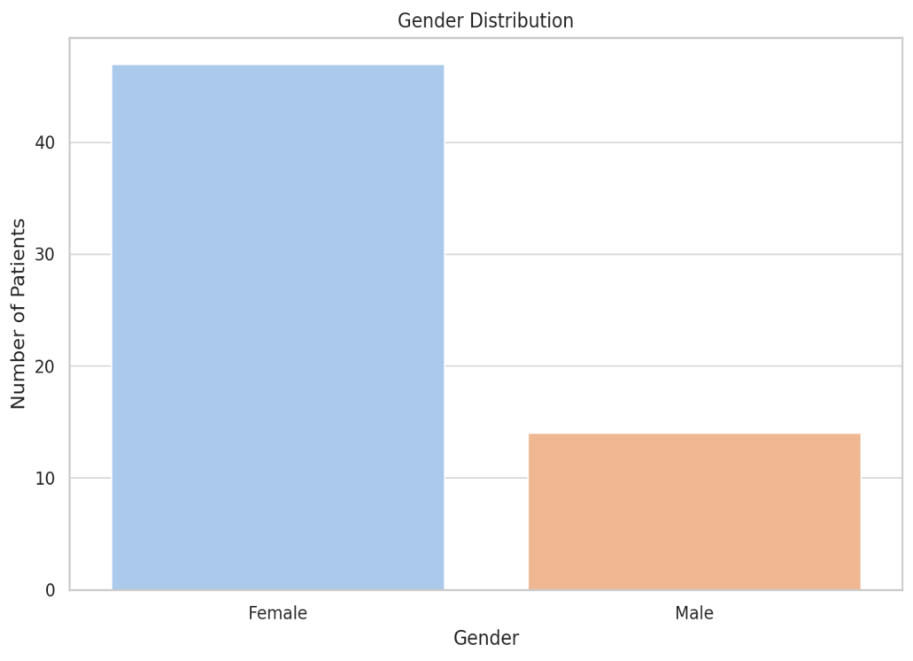
Figure 1. Show the distribution of Gender of the study population.

Common Symptoms; The most common symptoms reported was diarrhea 52.5% followed by Abdominal pain 27.1% and Weight loss 20.3%. in addition, 18.6% and 22% of cases were Present with Vomiting and Symptomatic anemia respectively

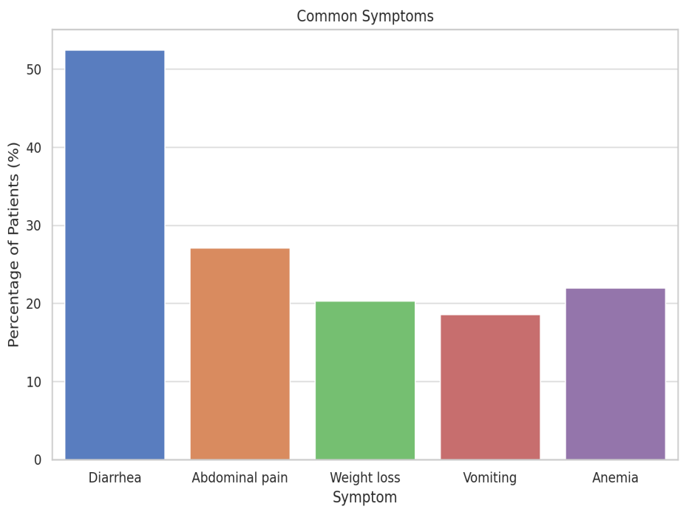
Figure2. Show Clinical presentation of the study population.

Diagnostic Classifications (Marsh Types) In this study biopsies were classified according to Marsh classification, there were 9 (14.8%) patients were in Marsh 0 category, 17 (27.9 %) patients who belonged to Marsh type 1, 8 (13.1%) patients were in Marsh II, 14 (23%) patients were in the Marsh IIIa type, 2 (3.3%) patients were in Marsh-IIIb, 1 (1.6%) patients were in Marsh IIIc and 10 (16.4%) patients were Missing/not specified

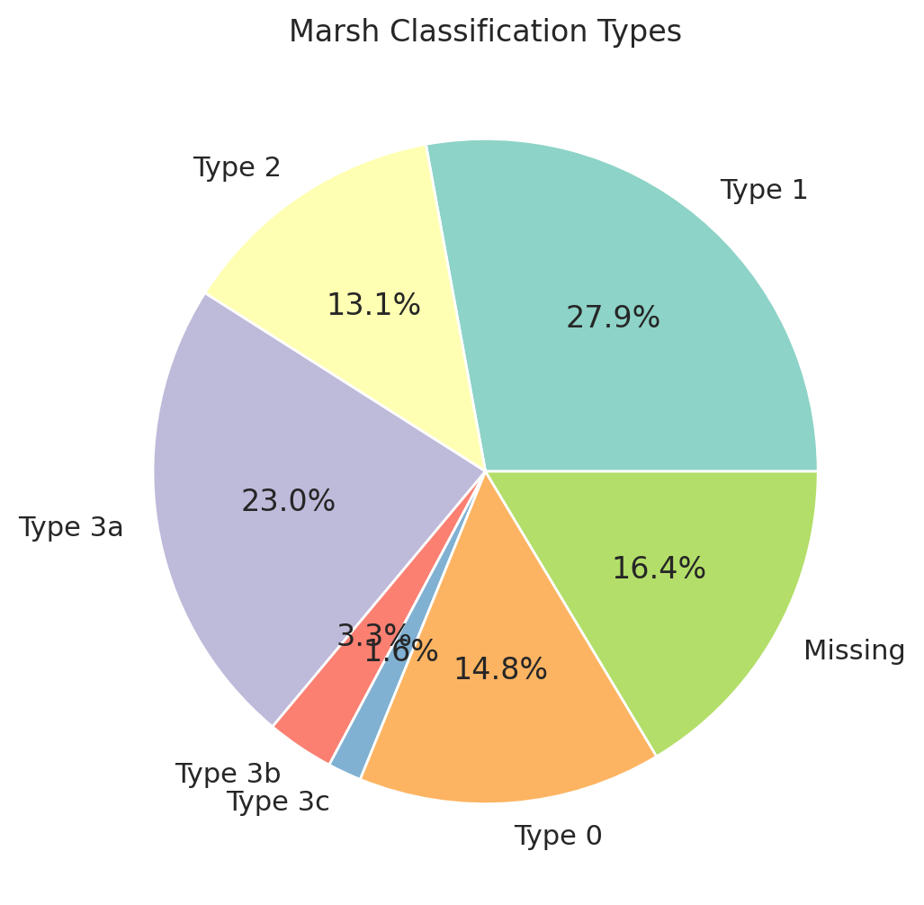
Figure 3. Show The Distribution of Marsh classification.

Association with other autoimmune disease Study was identifying (8 cases) had associated Hypothyroidism and 4 cases had medical history of Hyperthyroidism, 6 cases had associated Diabetes Mellitus and only one case had Thyroiditis and Rheumatoid arthritis. in addition, there were 4 cases had medical history of Liver disease,

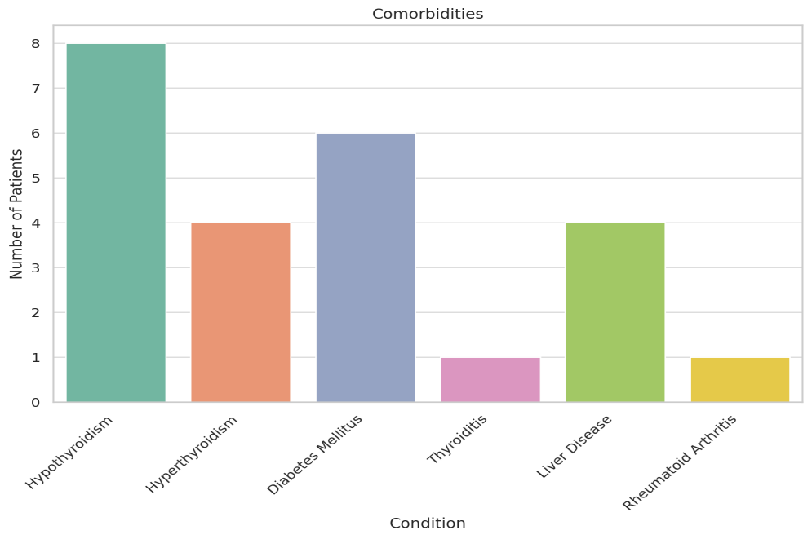
Figure 4. Show the association with other autoimmune disease.

Laboratory Findings Out of 61 cases of patients with celiac disease or suspected celiac disease, 34 cases having a Low haemoglobin, 37 of the cases have low Vitamin D and Low Calcium was in 18 of the cases ,) (Normal: 2.1–2.6 mmol/L)

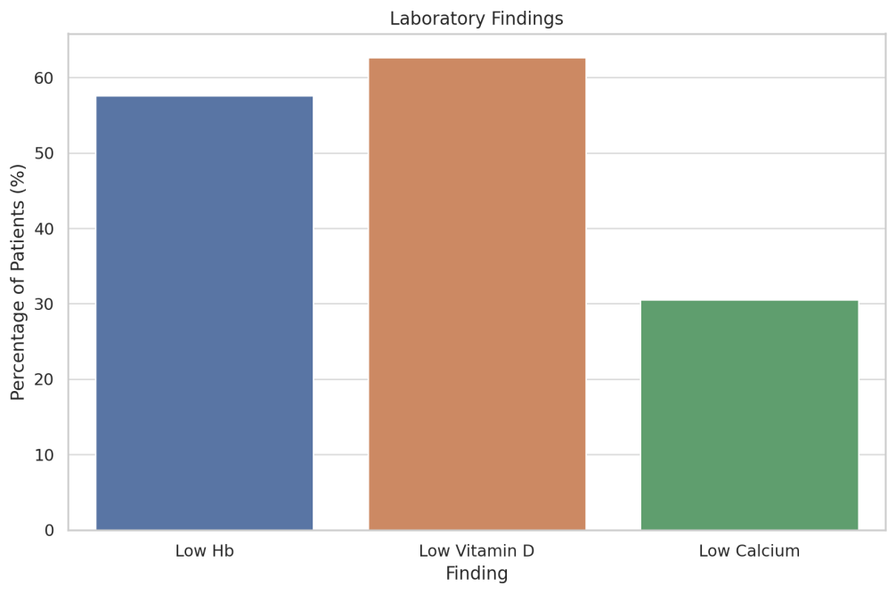
Figure 5. show Laboratory Findings of cases with celiac disease.

Treatment Adherence According to Treatment Adherence in this study, Gluten-free diet compliance was compliant in 79.3% of the patients and non-compliant in 20.7%.

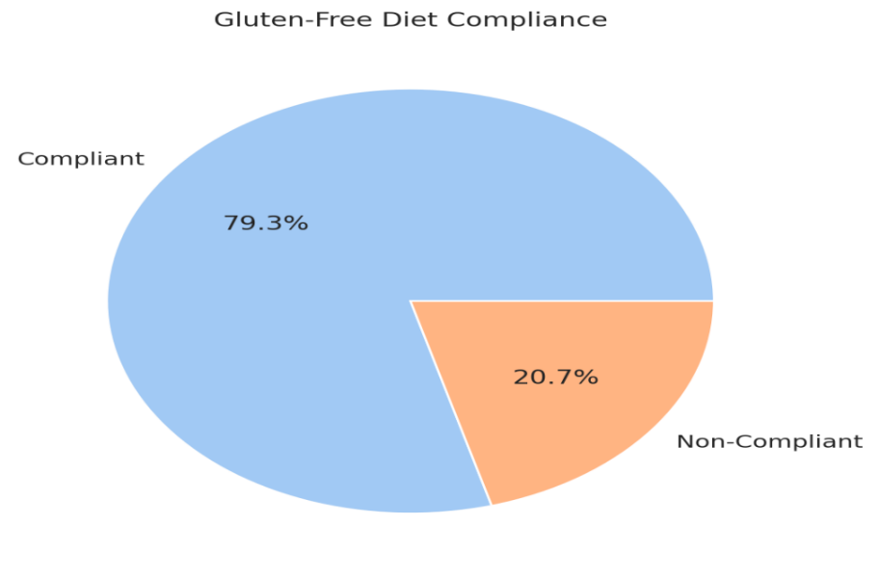

Figure 6. show Treatment Adherence of the study population on Gluten-free diet.

Discussion; This study looks at recent data from a group of patients and compares it to the previous research done and It shows both similarities and differences in how the celiac disease shows up. In this study there was a greater percentage of females that were diagnosed with CD as compared to males. Which agrees with the indication that it is twice frequent of celiac disease in females than males with ratio 2∶1 (10,12). This suggests that women are more likely to be diagnosed with CD than men, possibly attributed to hormonal influences and genetic factors (13) these results agree with our data in which the female’s number more than males.
In previous cohort study included 90 patients of celiac disease and females represented a greater percentage 60% of the pediatric patients with the mean age at diagnosis was 6.93 years (10) which is similar to other studies in which the mean age at diagnosis of CD in Oman was 7 years (14). Moreover, in previous study celiac disease patients were divided into two groups, one group was 1 to 7 years of age and the other group was 8 to 14 years of age and there were (74.2%) patients between 1 to 7 years and (25.8%) patients who fit the older age group (15).
CD patients may present with gastrointestinal or extraintestinal manifestations, the classical gastrointestinal symptoms include and abdominal pain, vomiting and diarrhea. The extraintestinal manifestations are correlated with gastrointestinal dysfunction which leads to various disorders affecting most of the body systems (16). The most common manifestations reported in our study were diarrhea (52.5%), Abdominal pain (27.1%), Weight loss (20.3%), Vomiting (18.6%) and symptomatic anemia 22% of cases. Previous study among 90 subjects of showed the most common manifestations that celiac disease children presented with are abdominal pain, followed by Weight loss and diarrhea (10)
Among factors that indicate a higher risk of celiac disease is the family history (7). It has been exhibited that disease is significantly higher in celiac disease patients’ relatives than in the general population. The risk of celiac disease developing among first-degree relatives was 4.5–7.5% and among second-degree relatives was 2.3–2.6%. It was identified more often in women than in men who were first-degree relatives of patient’s celiac patients (16). In a retrospective study conducted by Andari et al 2025 in tertiary care center in Lebanon, 11.1% of patients had a positive family history of celiac disease (10)
CD is more established among people with other autoimmune conditions, including diabetes mellitus (17). Our Study was identifying 8 cases had associated Hypothyroidism and 4 cases had medical history of Hyperthyroidism, 6 cases had associated Diabetes Mellitus and only one case had Thyroiditis and Rheumatoid arthritis. in addition, there were 4 cases had medical history of Liver disease, other cases have no associated autoimmune disease. Further study has shown that 17.8% had associated autoimmune condition such as type diabetes, moreover, 10% of the patients had past medical history of gastrointestinal diseases or inflammatory bowel disease. Family history of autoimmune disorder including type 1 diabetes or rheumatoid arthritis was present in 10% of the patients and 17.8% of patients had a positive family history of gastrointestinal diseases including inflammatory bowel disease or colon cancer (10)
The most common extraintestinal symptoms of celiac disease are anemia, folic acid deficiency, and vitamin B12 deficiency, moreover, deficiencies in the fat-soluble vitamins such as A, K, E and D among celiac disease patients are detected more often than in the general population (18). In our study, 34 of cases having a Low haemoglobin, 37 of case had low Vitamin D and 18 of cases had Low Calcium. In other cohort study, 26.7% of patients who had lower range of iron (10) In a study done by Lu C , et al showed that untreated patients have lower level of vitamin D than controls patients without CD (19). A meta-analysis of 26 studies reported lower vitamin D level among patients of celiac disease compared to the control (20). Ackerman et al. conducted a study in which celiac disease patients have lower mean levels of haemoglobin as well as had much more occurrences of longer periods of diarrhoea and anaemia as compared to those patients who did not have the disease (21)
In the 1990s, Marsh classified the histologic features of mucosal pathology of small intestine, which has been subjected to modifications in 1999 by Oberhuber et al. The modified Marsh-Oberhuber classification is presently used by several pathologists in order to assess the mucosal lesions of duodenum in celiac disease patients. This classification describes five stages of mucosal injury small-intestinal ranging from Type 0 (normal) to Type 4 (Atrophic type) although type 1 and type 2 mucosal changes are frequently not detectable, and abnormalities indicating type IIIa and type IIIb in the Marsh classification are fraught with a high level of interobserver variability, even among expert pathologists. (22)
In most of previous study there is variance in celiac disease stages by march classification, however, most of patients in our study was march classification I followed by IIIa. In other study. Among 97 patients 38.1% of the patients in Marsh III a, 19 (19.6%) patients were in Marsh 0, 15.5% were belong to Marsh III b, 17.5% were in marsh II and 4.1% were in the Marsh IIIc type (15). Lodhi et al. had demonstrated that Marsh IIIb had been the most frequently histological finding (37.9%), which was followed by Marsh IIIc (26.3%) then Marsh IIIa (7.4%) (23). Dutta et al. had showed that among the patents of celiac disease in India Marsh IIIc was the most recurrent identification (38.39%) (24). Emami et al. had reported that Marsh IIIb and IIIa were frequently noticed among 38% of patients presenting at the Irani population sample followed by Marsh IIIc (24%) (25). In our study Type I was the most prevalent, then III 3a type according to the Marsh classification,

Adherence to a gluten-free diet is the only management of celiac disease patients. However, strict adherence to the gluten-free- diet is often challenging due to high cost and limited options (10) In our study, the gluten-free diet was found to be suitable for the most of cases, while a smaller portion of patients did not respond well to it. This is consistence with other study conducted by Cekin et al. established that after restricted gluten-free diet, the patient's mean level of haemoglobin improved (26). However, half of the patient in other study were in remission at their follow up visit while 21.1% of the patient’s had an improvement in serological markers and their symptoms (10)

Limitations; Although our study is aimed to describe the gender, the common clinical presentations, diagnostic classifications, association with other autoimmune disease, and the effect of the gluten-free-diet on celiac disease patients registered at Benghazi medical center from first of June 2021 up to 30th of June 2024. The retrospective study limited our ability to collect complete data and did not permit us to have applicable long-term follow up in order to assess compliance with GFD.
Conclusion; The most common symptoms of patients with celiac disease in this study presented with are diarrhea, Abdominal pain, Weight loss, Vomiting and Symptomatic anemia. In this study, the most common laboratory abnormality was vitamin D deficiency, followed by low hemoglobin levels and reduced calcium concentrations. The most common comorbidities were Hypothyroidism then followed by diabetes mellitus. In the Marsh classification types, Type I was the most prevalent, then III 3a type. Finally, the gluten-free diet was found to be suitable for the most of cases, while a smaller portion of patients did not respond well to it. The identification of early symptoms, early diagnosis and adherence to the GFD are significance in order to avoid long term disease complications.
References;
- . Tye-Din JA, Galipeau HJ, Agardh D. Celiac Disease: A Review of Current Concepts in Pathogenesis, Prevention, and Novel Therapies. Front Pediatr. 2018;6:350. [PMC free article] [PubMed]

- Austin K, Deiss-Yehiely N, Alexander JT. Diagnosis and Management of Celiac Disease. JAMA. 2024 Jul 16;332(3):249-250. [PubMed]

- Singh P, Arora A, Strand TA, Leffler DA, Catassi C, Green PH, Kelly Ahuja V, Makharia GK. Global Prevalence of Celiac Disease: Systematic Review and Meta-analysis. Clin Gastroenterol Hepatol. 2018 Jun;16(6):823-836.e2. [PubMed]

- . Chiang JL, Maahs DM, Garvey KC, Hood KK, Laffel LM, Weinzimer SA, Wolfsdorf JI, Schatz D. Type 1 Diabetes in Children and Adolescents: A Position Statement by the American Diabetes Association. Diabetes Care. 2018 Sep;41(9):2026-2044. [PMC free article] [PubMed]

- . Vivas S, Ruiz de Morales JM, Fernandez M, Hernando M, Herrero B, Casqueiro J, Gutierrez S. Age-related clinical, serological, and histopathological features of celiac disease. Am J Gastroenterol. 2008 Sep;103(9):2360-5; quiz 2366. [PubMed]

- . Kori M, Goldstein S, Hofi L, Topf-Olivestone C. Adherence to gluten-free diet and follow-up of pediatric celiac disease patients, during childhood and after transition to adult care. Eur J Pediatr. 2021 Jun;180(6):1817-1823. [PubMed]
- Naiyana Gujral, Hugh J Freeman, Alan BR Thomson,( 2012) Celiac disease: Prevalence, diagnosis, pathogenesis and treatment. World J Gastroenterol November 14; 18(42): 6036-6059
- . Caio, G., Volta, U., Sapone, A., Leffler, D. A., De Giorgio, R., Catassi, C Fasano, A. (2019). Celiac disease: a comprehensive current eview
- Daley SF, Posner EB, Haseeb M. Celiac Disease. [Updated 2025 Feb 4]. I: StatPearls [Internet]. Treasure Island (FL): StatPearls Publishing
- Dana Andari ,Rima Hanna-Wakim, Sarah Khafaja and Nadine Yazbeck (2025). clinical presentations and outcomes of celiac disease in children and adolescents at a tertiary care center in Lebanon, front. Paediatrics, 13, 1
- Rubio-Tapia A, Hill ID, Semrad C, Kelly CP, Greer KB, Limketkai BN, Lebwohl B. American College of Gastroenterology Guidelines Update: Diagnosis and Management of Celiac Disease. Am J Gastroenterol. 2023 Jan 01;118(1):59-76. [PubMed]
- Singh P, Arora A, Strand TA, Leffler DA, Catassi C, Green PH, Kelly CP, Ahuja V, Makharia GK. Global Prevalence of Celiac Disease: Systematic Review and Meta-analysis. Clin Gastroenterol Hepatol. 2018 Jun;16(6):823-836.e2. [PubMed]
- Jansson-Knodell CL, Hujoel IA, West CP, Taneja V, Prokop LJ, Rubio-Tapia A, Murray JA. Sex Difference in Celiac Disease in Undiagnosed Populations: A Systematic Review and Meta-analysis. Clin Gastroenterol Hepatol. 2019 Sep;17(10):1954-1968.e13. [PubMed]
- Al-Lawati TT, Al-Musawi HS. Celiac disease in Oman: a tertiary centre experience. Oman Med J. (2013) 28(1):70–2. doi: 10.5001/omj.2013.17
- Muzammal Ghafoor, Farooq Ikram, Saeed Zaman*, Junaid Bashir, Samina Tabassum**, Muhammad Waleed Babar (2022). Celiac Disease Investigation with Marsh Classification in Paediatric Population. Pak Armed Forces Med; 72(4): 1164-1167. DOI: https://doi.org/10.51253/pafmj.v72i4.7212
- Marek K. Kowalski, Danuta Domżał-Magrowska, Ewa Małecka-Wojciesko (2025). Celiac Disease—Narrative Review on Progress in Celiac Disease. Food 11;14(6):959. doi: 10.3390/foods14060959.
- Kori M, Goldstein S, Hofi L, Topf-Olivestone C. Adherence to gluten-free diet and follow-up of pediatric celiac disease patients, during childhood and after transition to adult care. Eur J Pediatr. 2021 Jun;180(6):1817-1823. [PubMed]
- Montón Rodríguez, C.; Sánchez Serrano, J.; Poyatos García, P.; Abril García, C.; Gómez Medina, C.; Capilla-Lozano, M.; Lluch Garcia, P.; Pascual Moreno, I. Liver disorders and celiac disease. Rev. Esp. Enferm. Dig. 2024, 116, 41–42. [Google Scholar] [CrossRef]

- Lu C, Zhou W, He X, Zhou X, Yu C. Vitamin D status and vitamin D receptor genotypes in celiac disease: a meta-analysis. Crit Rev Food Sci Nutr. (2021) 61(12):2098–106. doi: 10.1080/10408398.2020.1772716

- Sun, Y.; Zhou, Q.; Tian, D.; Zhou, J.; Dong, S. Relationship between vitamin D levels and pediatric celiac disease: A systematic review and meta-analysis. BMC Pediatr. 2024, 24, 185. [Google Scholar] [CrossRef]

- Ackerman Z, Eliakim R, Stalnikowicz R, Rachmilewitz D. Small bowel biopsy in the endoscopic evaluation of adults with iron deficiency anemia. Am J Gastroenterol 1996; 91: 2099-2102.

- Fei Bao,; Peter H. R. Green,; Govind Bhagat, (2012). An Update on Celiac Disease Histopathology and the Road Ahead. (Arch Pathol Lab Med. 2012;136:735–745; doi: 10.5858/ arpa.2011-0572-RA)
- Lodhi MA, Saleem Z, Ayub A, Munir T, Hassan S. Diagnostic accuracy of IgA anti-tissue transglutaminase antibody in the diagnosis of celiac disease taking histopathology as gold standard. Pak Armed Forces Med 2021; 71(2): 418-421.

- Dutta AK, Chacko A, Avinash B. Suboptimal performance of IgG anti-tissue transglutaminase in the diagnosis of celiac disease in a tropical country. Dig Dis Sci 2010; 55(3): 698-702.

- Emami MH, Karimi S, Kouhestani S, Hashemi M, Taheri H. Diagnostic accuracy of IgA anti-tissue transglutaminase in patients suspected of having coeliac disease in Iran. J Gastrointestin Liver Dis 2008; 17(2): 141-146.

- Çekın AH, Çekın Y, Sezer C. Celiac disease prevalence in patients with iron deficiency anemia. Turk J Gastroenterol 2012; 23(5): 490-495.

Compliance with ethical standards
Disclosure of conflict of interest
The authors declare that they have no conflict of interest.

Disclaimer/Publisher’s Note: The statements, opinions, and data contained in all publications are solely those of the individual author(s) and contributor(s) and not of JLABW and/or the editor(s). JLABW and/or the editor(s) disclaim responsibility for any injury to people or property resulting from any ideas, methods, instructions, or products referred to in the content.

